**ADDENDUM 1**

**5.1**

**RACE COURSE**

Whether Inner or outer course will be sailed, will be displayed on the starting vessel by I Flag (Inner) or O Flag (Outer)

Inner Course: Start – 1a – 1b – 2 – 1a - 3a - Finish

Outer Course: Start – 1a – 3a – 4 - 3a - 3b - Finish

Start Line 5 boat lengths approximately. Race length 10 -12 minutes. All Marks to be rounded starboard.

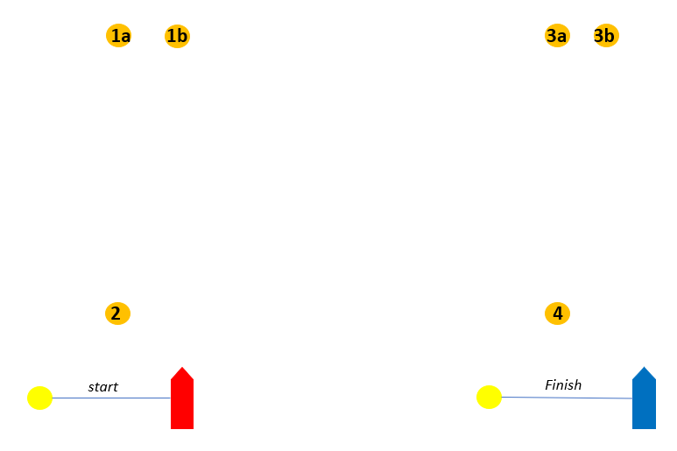

**ADDENDUM C**

**Penalties for damage resulting from contact between boats racing**

SI 10 permits umpires to determine the penalty for breaking RRS 14 without a hearing. This appendix explains how damage will be assessed and prescribes the  appropriate level of penalties. The Protest Committee may impose additional  penalties if it has good reason to do so. There are a number of things we are trying to  achieve with penalties for damage:

∙ Minimise damage to keep costs down and avoid delays while boats are being  repaired.

∙ Ensure that penalties are consistent and fit the breach.

∙ Keep race results “on the water”.

∙ Give more sailing to everybody for the same entry fee!

**Damage Levels**

|  |  |  |
| --- | --- | --- |
| **Level** | **Extent** | **Effect** |
| Level A- Minor Damage | Up to 1 man hour to repair | Boat may race without  repair |
| Level B- Significant  Damage | More than 1 hour and up to 5 man hours to repair | Boat may need some  (temporary) work before  racing again. |
| Level C- Major Damage | More than 5 man hours to  repair | Significant work required  before racing again. |

**Penalties**

Race-win penalties may be imposed by umpires after a race to boats that break RRS  14. Any penalties are deducted from one boats’ or both boats’ team race wins for the  series in which the damage occurred.

|  |  |
| --- | --- |
| **Level** | **Race Win Penalty** |
| Level A | No Penalty |
| Level B | ½ race win |
| Level C | 1 race win |

**Deductions from Damage Deposits**

Any deductions from damage deposits are a matter for the Organising Authority and do not affect any race win penalties applied by the Umpires or Protest Committee.  Subsequent assessments of the damage level after further inspection, whether the  level turns out to be higher or lower, will have no effect on the race wins penalties  given on the water.

**ADDENDUM D**

**DAMAGE CHARGES**

This appendix is included only for information and guidance and does not form part of this Notice or the  Sailing Instructions. The charges below are all applicable where it is obvious that the user caused  damage or loss due to misuse.

|  |  |  |
| --- | --- | --- |
| **Damage** | **Definition** | **Cost** |
| Hull | Gel coat or capping nicks (per instance) | €200,00 |
|  | Minor hull damage not requiring lamination | €300,00 |
|  | Heavy hull damage requiring lamination | €500,00 |
| Keel/Rudder | Minor damage | €250,00 |
|  | Heavy damage | €500,00 |
| Shrouds | Bent shroud/turnbuckle | €190,00 |
| Sail damage | Rips smaller than 10cm | €90,00 |
|  | Rips larger than 10cm up to 40cm | €200,00 |
|  | Rips larger than 40cm | €250,00 |
|  | Sail write off | €500,00 |
| Flags | Loss | €15,00 |
| Sheets | Damage or loss (per sheet) | €75,00 |
| Halyards | Damage or loss (per halyard) | €200,00 |
| Deck fitting | Damage or loss – small items | €60,00 |
|  | Damage or loss – large items | €90,00 |
| Hatches | Minor damage | €90,00 |
|  | Major damage | €400,00 |
| Tiller extension | Break | €50,00 |
| Tank-tops | Failure to Return at end of event (even if  returned later)  Loss | €10,00  €20,00 |

**ADDENDUM E**

**HANDLING BOATS**

1. GENERAL

While all reasonable steps are taken to equalize the boats, variations will not be grounds for redress. This changes RRS 62.

2 PROHIBITED ITEMS and ACTIONS Except in an emergency or in order to prevent damage or injury, or when directed by an umpire otherwise, the following are prohibited.

2.1 Any additions, omissions or alterations to the equipment supplied. In particular the cutting or shortening of any sheets, control lines or other running rigging.

2.2 The use of any equipment for a purpose other than that intended or specifically permitted. 2.3 The replacement of any equipment without the sanction of the RC.

2.4 Sailing the boat in a manner that it is reasonable to predict would cause significant damage.

2.5 Moving equipment from its normal stowage position except when being used.

2.6 Boarding a boat without prior permission.

2.7 Taking a boat from its berth or mooring without having paid the required damage deposit or having permission from the RC.

2.8 Hauling out a boat or cleaning surfaces below the waterline.

2.9 Using a flattener as a reef.

2.10 Attaching lines to the fabric of spinnakers.

2.11 Perforating sails, even to attach tell tales.

2.12 Radio transmission (including mobile telephones), except to report damage or in response to a request from the RC.

2.13 Adjusting or altering the tension of standing rigging, excluding the backstay.

2.14 Using a winch to adjust the mainsheet, backstay or vang.

2.15 Using a reef line as an outhaul.

2.16 Omitting any headsail car or turning block before sheeting onto a winch.

2.17 The use of electronic instruments other than compass and watches.

2.18 Using the spinnaker pole to wing out the foresail.

2.19 Attaching the spinnaker pole to the shroud or shroud turnbuckle at any time.

2.20 Marking directly on the hull or deck with permanent ink.

2.21 The use of the shrouds (including any inner shrouds) above the lower bottle screw (turnbuckle) to facilitate tacking, gybing or steering

2.22 A breach of SI Appendix F 2.21 is not open to protest by boats but may be subject to action by Umpires. This changes RRS 60.1.

3 PERMITTED ITEMS and ACTIONS.

The following are permitted.

3.1 Taking on board and making appropriate use the following equipment :

(a) Basic hand tools consisting of knife, pliers and screwdrivers but excluding hammers and saws.

(b) Adhesive tape

(c) Line (elastic or otherwise of 4 mm diameter or less)

(d) Tell tale material

(e) Notebook

(f) Watch, timers and hand held compass

(g) Shackles and clevis pins

(h) Velcro tape

3.2 The use of camera equipment (e.g. GoPro) on board is permitted.

**ADDENDUM F**

**EQUIPMENT LIST**

The following non-fixed items, provided by the OA, are to be carried on board at all times in their designated place while sailing. Any loss shall be reported on the daily damage report.

SAILS and SAILING EQUIPMENT

* Mainsail and set of battens Small headsail
* Two headsail sheets
* Joystick
* Genoa cars

SAFETY GEAR

* One bucket

EXTRA

* Two mooring lines, one fender